21.80: (a)
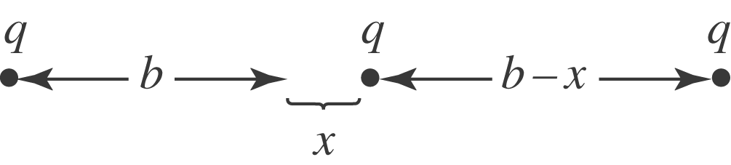
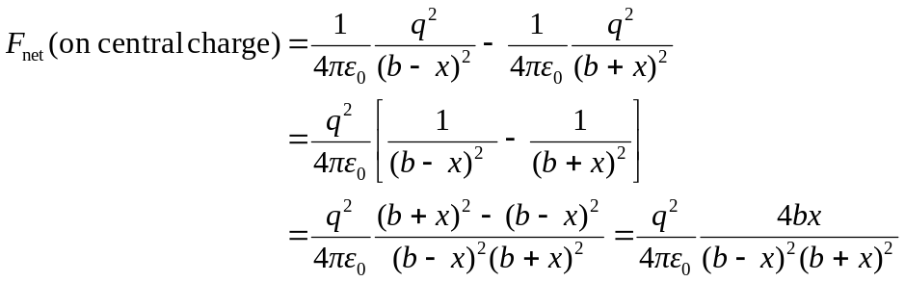
For 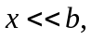 this expression becomes
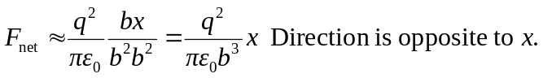
(b) 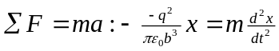
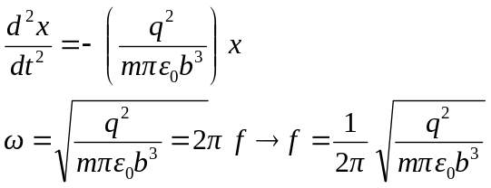
(c)

